**DATA 255- Deep Learning Project**

**Creating Art through the lens of GAN**

**Guided by:** *Prof. Simon Shim PhD*

**Submitted by:**

*Manisha Paliwal*

*Shounak Upadhyay*

*Huan Nguyen*

*Madhur Parakh*

*Smit Vinod Savla*

**Introduction**

Image Generation models have been in the market for more than a few years but with the boom in usage of Generative Adversarial Network(GAN), they became even more popular. Using a computer to draw an image from random input is something we couldn’t have even thought about up until a couple decades ago. With the success of advanced machine learning models, not only can we generate images from scratch, we can modify them such that they look very similar to a particular design or an artist’s handiwork.

Even though multiple GAN and other models (K. Gregor et. al) have been implemented in the image generation and translation field, in this paper we are trying to create multiple models for style transfer using Pix2Pix, Cycle GAN, DCGAN, Transformer etc and compare their outputs. We are focusing on Monet paintings based on the Kaggle competition, ‘I’m something of a painter myself’. Our model should be general enough that it can be tuned to perform image translation to different artists’ “je ne sais quoi” as well.

**Background and Motivation**

Image generation is when we create a fake image from random inputs. Image translation is when we convert one image to another and style transfer is when we do image translation such that a desired style or pattern is achieved in the outcome. In our project we have tried to do style transfer on images to monet style painting. The motivation behind the project is threefold. Firstly, GAN is a new and interesting concept which we wanted to explore and experiment with. The next is, ‘I’m something of a painter’ is one of the most popular Kaggle Competition in this area and we are participating in it as a part of this project. Lastly, by working on this project we are also creating models which can act as filters on social media.

**Literature Review**

Multiple machine learning and deep learning based models have been constructed which work on the task of image generation and style transfer. Some of the most popular ones are described in the below table which consists of models such as DRAW by Google DeepMind and AI Painting. Most of these models only work efficiently in case of limited datasets, which is usually MNIST or SVHN.

| Author | Model | Description | Year | Ref. |
| --- | --- | --- | --- | --- |
| Karol Gregor et. al (DeepMind) | Deep Recurrent Attentive Writer (DRAW) | Sequential image generation using recurrent NN. Good for generating images similar to MNIST or SVHN. | 2015 | [1] |
| C. Zhang et. al | StackGAN++, BDA-CE, Neural Network | AI Painting: Four step process with GAN for image generation, Autoencoder and NN for style transfer. | 2018 | [2] |
| Han Meng et. al | GAN with Linear and Convolutional layers | Performance on MNIST data for image generation is compared for the two models. | 2021 | [3] |
| Colin Chen et. al | Cycle GAN | Style transfer of human face to cartoon using Cycle-GAN and hyperparameter tuning. | 2022 | [4] |

**Related Works**

Models which can work on the monet dataset have not been intensively researched yet but several have been created as a part of this competition. Cycle-GAN and its modifications are some of the most popular models. There are also other models such as RNN, PIX2PIX and custom ones which generate really good results. In fact, the model which currently holds the topmost position in the competition is a completely new architecture using something called Gram Matrix.

**System Architecture**

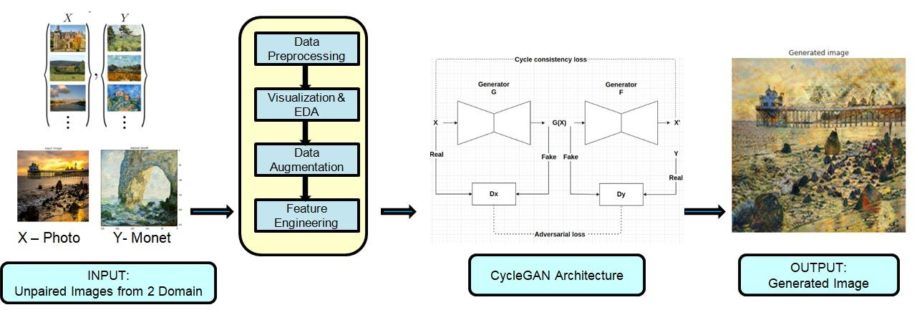

Fig 1. System Architecture

Our system architecture consists of the above mentioned steps that shows the overall high level architecture. Input would be the Photo and Monet Images from 2 Domains. The images are first preprocessed, then visualization & EDA are done to show how the data looks and what data patterns can be inferred. After that, Data Augmentation is done as a part of Data Transformation and then feature engineering is performed to convert the images into feature vectors. Next is to apply different CycleGAN models over them, train both Generator and Discriminator and generate the output images(real looking fake images).

**Data Preprocessing**

**Dataset source and Description:**

The data used for this project is gathered from the kaggle competition, ‘I’m Something of a Painter Myself’. The dataset consists of 300 High resolution Monet Images in jpg format and 7038 High Resolution Photo Images in jpg format.

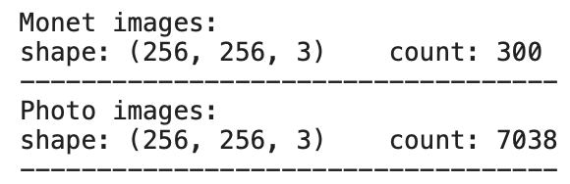

Fig 2. Shape of dataset

**Data Cleaning and Preprocessing**

Our original image dataset is of high resolution and good quality and does not need much cleaning and pre-processing. Several steps are still taken to ensure smooth data pipelines. Images have been resized to (3,256,256) and then they are normalized with mean=0.5 & std=0.5. To process the data into a model without memory issues, images are divided into multiple batches with the use of the DataLoader library with batch size as 8 for train and batch size as 16 for test.

**Data Visualization and EDA**

Image dataset has been explored and experimented on to understand the dataset properties. Following images show RGB composition and hue adjustment. RGB composition basically tells us the levels of red, green and blue composition in an image. We have also shown some samples below from our dataset, the monet images and the photos that we are trying to style transfer on.

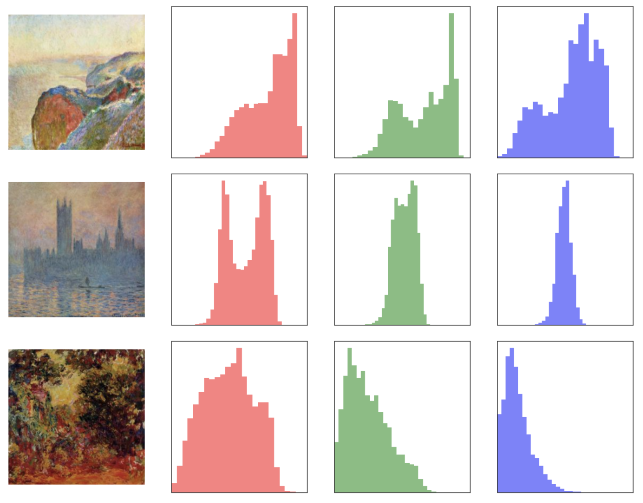

Fig 3. RGB scale of input image

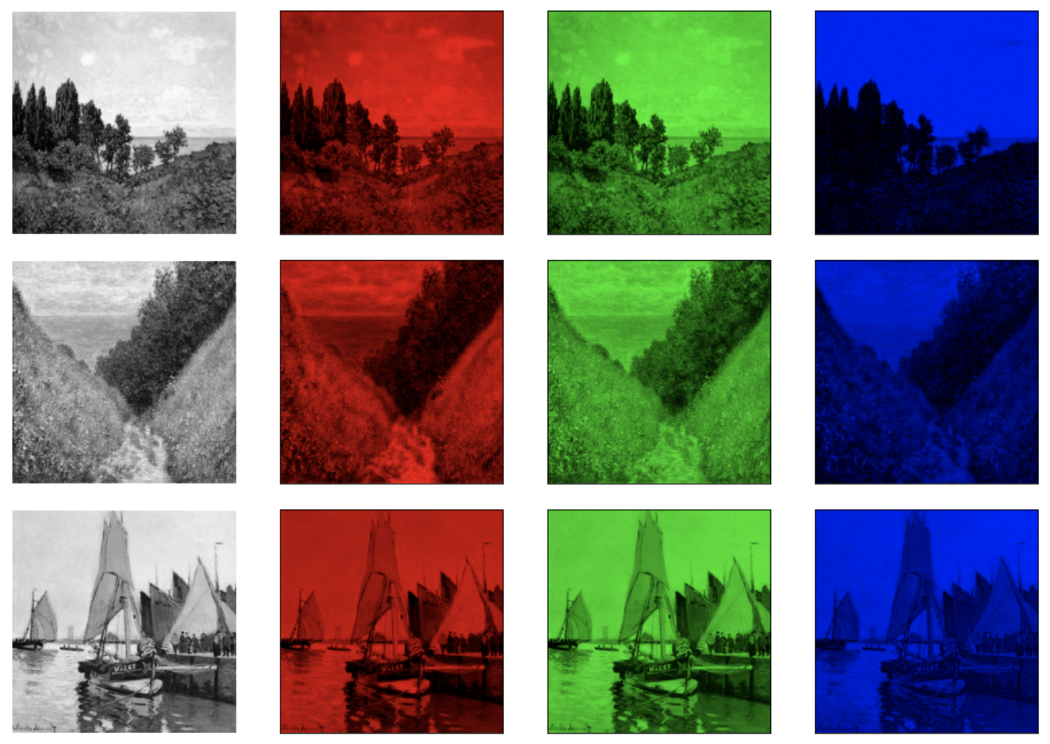

Fig 4. RGB channel transformation on image

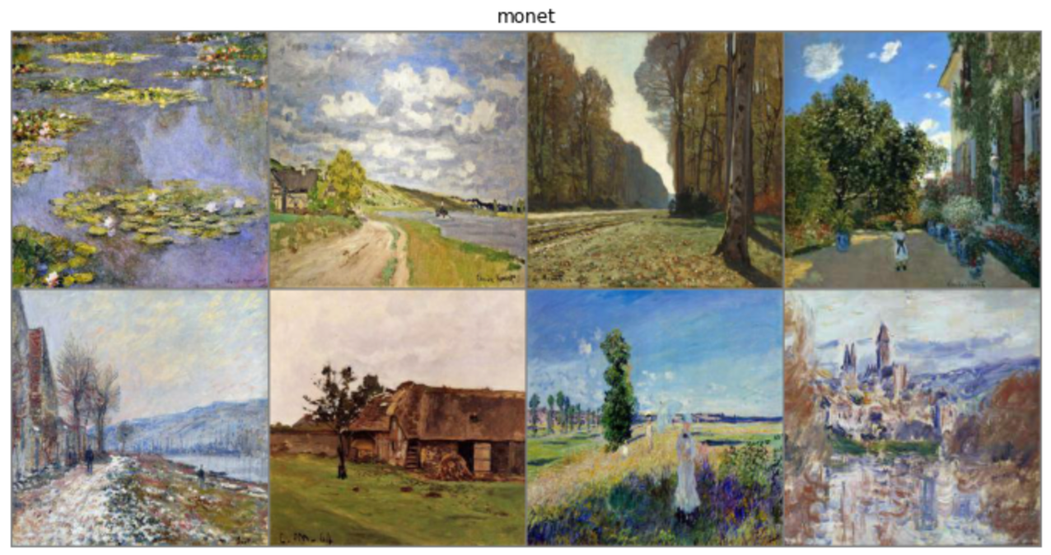

Fig 5. Input Monet Image

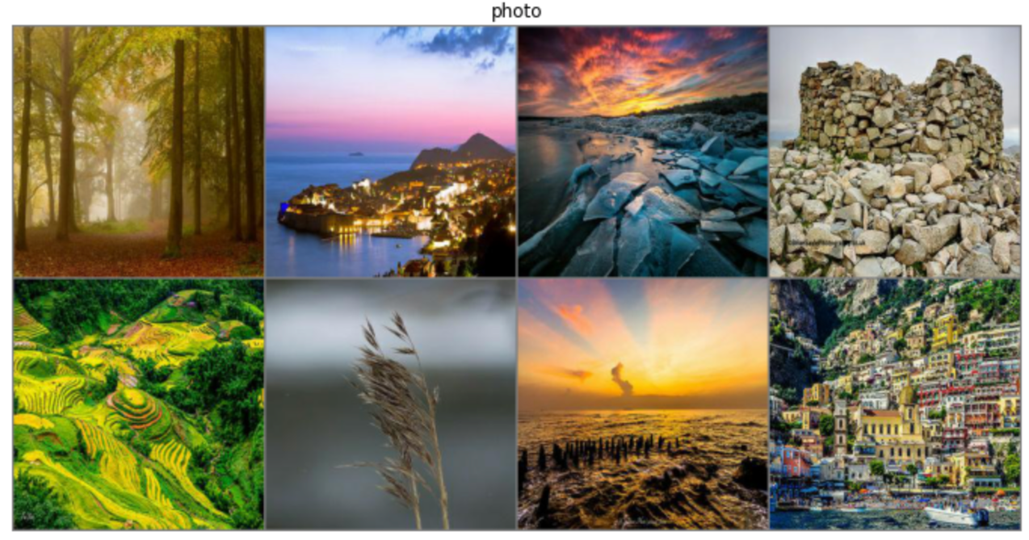

Fig 6. Input Photo Image

**Data Transformation- Augmentation**

Image data that we have used for our project consists of around 300 monet paintings.Providing training data to the model helps avoid overfitting and improves performance.As we are performing style transfer, a lot of significant changes shall be avoided to keep monet style intact. Below mentioned image augmentation is used to transform and augment the images. For photos we have sufficient data to proceed with modeling therefore, only monet images are considered for data transformation and augmentation.

**Image Rotation:**

Images are rotated by a predetermined degree. As shown in below image rotation at 90 degree is performed.

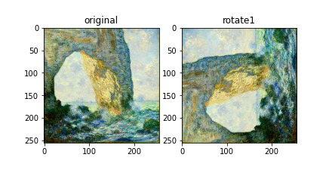

Fig 7. Original and 90 degree image rotation

**Image Flip:**

Image Flipping is the process of mirroring the images. Flipping can be performed horizontally or vertically. In below image we can see original image is flipped horizontally and then rotated

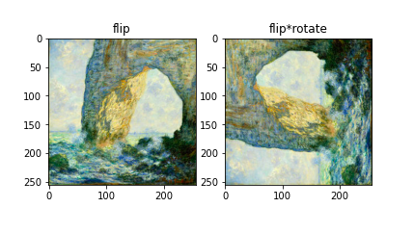

Fig 8. Flip and Flip rotate image

In the below example, the image is flipped upside down.

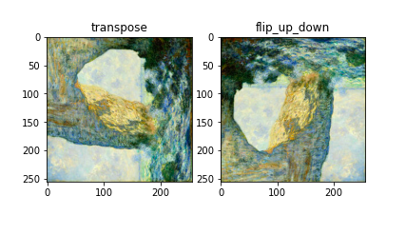

Fig 9. Transpose and Flip up down

**Image Contrast and Image Hue:**

Another methods in which images are augmented are by experimenting with the image contrast and hue.

This layer will modify the contrast of a picture or photos at random using a random factor. During training, contrast is modified individually for each channel of each picture.Image hue further defines the color channel of the image.

Below example shows image contrast and hue with respect to the original image.

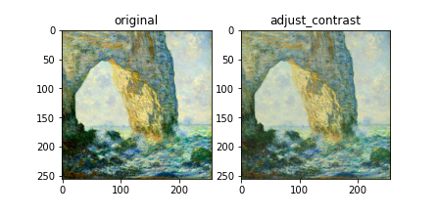

Fig 10. Original and adjusted Contrast image

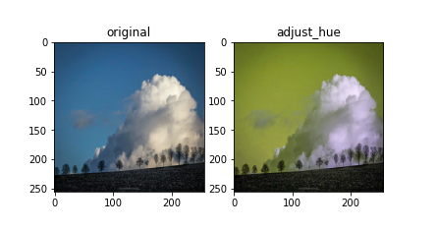

Fig 11. Original and Adjusted hue image

**Feature Engineering**

Feature Engineering for image data is the process to remove unnecessary noise from images. We simplify the challenge by isolating the most crucial component of an image like cropping the image to remove unnecessary background, performing gray scaling to image complexity in turn model complexity, performing edge detection in object detection scenarios , image channel detection (RGB) etc.

In our project we are using images to generate new images with the use of the GAN model. In our scenario, the dataset provided is of high resolution and consistent contrast and brightness. Therefore, the only use case is to convert the images from (H,W,C) shape into tensorflow vectors.

Therefore, we converted the Image with specific (Height x Width x Channel) in the range [0, 255] to a torch.FloatTensor of shape (Channel x Height x Width) . All the images belong to at least one of the RGB modes.Tensors are returned with scaling to further use for model training as shown in below image.

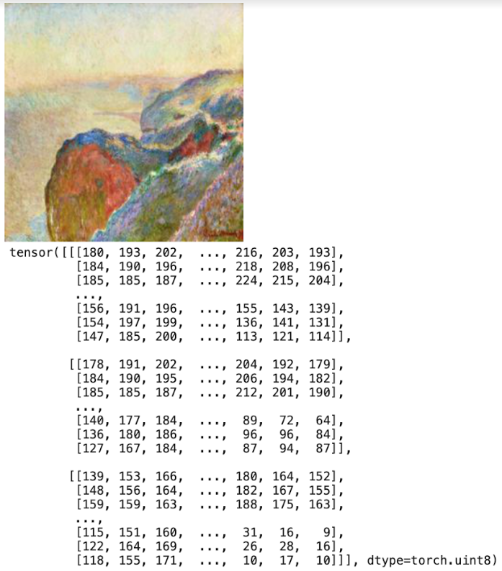

Fig 12. Feature engineered sample image

**Proposed Solutions**

As a part of Proposed Models, we have implemented 4 Models for this kaggle competition. First one is Basic CycleGAN and then experimented with different architectures to improve the Cyclegan.

1. CycleGAN with ReLU
2. Improved CycleGAN
3. Pix2PiX based CycleGAN
4. DCGAN based CycleGAN

**1) CycleGAN with ReLU**:

In this model, basic Cycle GAN is experimented using ReLU Activation function. Here the model flow follows Generator to generate images in Monet style using Residual network and discriminator to differentiate between generated monet painting and actual monet painting.

**Generator:**

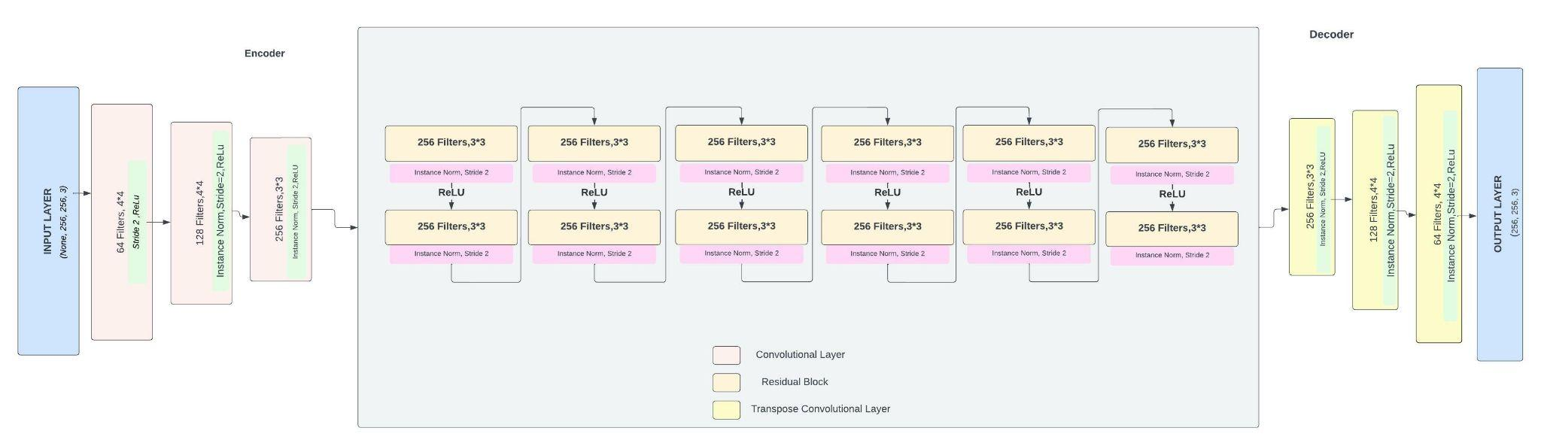

Fig 13. Generator Architecture

The generator part of the GAN model follows three different layers, encoders, decoders and residual layers. The first encoder layer consists of a Convolutional layer, where the image size is reduced. Three convolutional layers are applied before providing it with the residual layer, for each convolutional layer, the size of image is reduced from 128 to 64 to 32. Finally the reduced size image 32*32 is provided to the residual layer. The residual layer consists of 6 blocks, where each block learns the transformation of image. In our case the transformation is from photo to monet style painting. The task of the residual block is to provide the output of the previous layer and the image input as the input to the next layer, only one ReLU activation function is applied to each block of the residual layer. After 6 blocks of residual layer, and learning the pattern transformation of image, the generator than transforms the image back to its original size in three transpose convolutional layers from 32 to 63 to 128 using ReLU Activation function and finally the generated output in Generator is provide using the tanh activation function along with resizing the image to its original size of 256*256.

**Discriminator:**

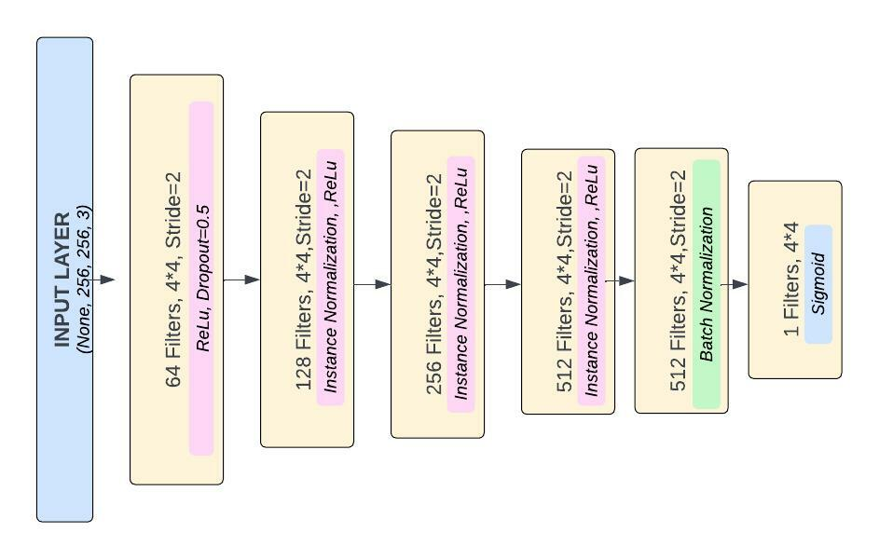

Fig 14. Discriminator Architecture

The discriminator part of GAN are actually image classifiers, which classify the images as 0 and 1, where real images are classified with an output close to 1 and fake images are classified with an output close to 0. The discriminator model uses two different types of normalization techniques when converting an image to reduced size and more features, first one being batch normalization and second one instance normalization. Instance normalization is highly recognized for style transfer. The discriminator uses a Convolutional layer wit input image of size 128*128*3 and then reduces the size of the image from 128 to 64 to 32 to 16 to 8. The output of the discriminator is a 8*8*1 reduced size image, where the 1 determines the classification part for discriminator. A ReLU Activation function is used when using a Convolutional layer.

**Hyperparameters:**

The learning rate used for modeling is 0.0002, the optimizers used for generator and discriminators are adam optimizers, there are total 6 blocks in the residual layer, the activation function used in each layer is ReLU Activation function.

**Experiments:**

* Initially tried working with Leaky ReLU activation function, but the model performed better with ReLU activation function.
* SGD optimizer was another choice of optimizer, but performance of Adam optimizer was better.
* Added a dropout layer in the Generator function, so to remove overfitting of data when generating the images.
* Trained the model for 250 epochs to get the better performance of the model

**Model Justification:**

When performing image style transfer to change the style of input image one of the best known models is CycleGAN. In this model architecture we have implemented CycleGAN using Residual block and ReLU activation function.

**2) Improved CycleGAN:**

This is an improved version of Basic CycleGAN that we have tried to achieve through a different model architecture.

**Model Architecture:**

In this model, we have experimented with the Basic CycleGAN with the better Transformation layers that included a modified residual block described below in the Generator Model to improve the Model performance.

# **Generator model**

The generator generates the images from a specific domain. In CycleGAN architecture, as we know that there are 2 generators. So, we have implemented one generator that will take the photos and will generate Monet paints, and the other generator will do the reverse by taking Monet paintings and generating photos, however to improve the performance, we have created a different model architecture that consists of Encoder, Transformer and Decoder blocks for Generator model.

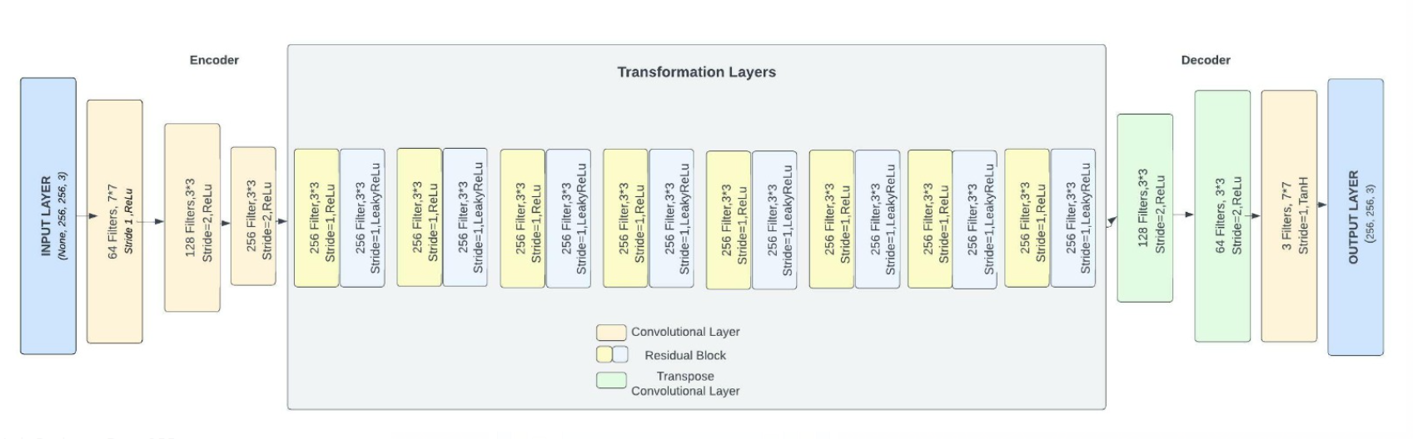

Fig. 15 Improved Cycle GAN generator architecture

* **Encoder block:** In this block, we apply 3 convolutional filters layers over the given input images and extract the features. Each convolution layer will add higher level features progressively, so features are increasing. Also, we are compressing the sizes of images. Result of Encoder will be a feature vector of images.
* **Transformation Layers Block:** Here, we apply convolutional filters to find relevant data patterns by combining different nearby features of an image. We have used 8 layers of ResNet blocks in this layer. One of the main aims of this layer is to retain the characteristic of original input images like size, shape etc. So, features will remain constant at this layer. Each Residual Block consists of a 2DConv layer, ReLU, another 2DConv Layer, Leaky Relu in sequence.
* **Decoder block:** This layer is the exact opposite of the Encoder layer. In this layer, we apply 3 convolutional filters and build back the low level features from the feature vector that we generated from the Encoder while also increasing data resolution.So, we are applying a deconvolution convolution layer and then converting this low level feature back to the image in domain B and we will get the generated image

# **Discriminator model**

The discriminator is a Convolutional Network that is used for adversarial training of the network to differentiate real images from the generated images that have been generated by a generator model.

We have tried to improve performance on Discriminator by creating the below architecture by applying 4 Convolutional filters while also adding Instance Normalization and ReLU in each layer. Here, we extract the features from the image and then decide if those features belong to that particular category or not. So, to generate a 1 dimensional output, we will add a final convolution layer with Sigmoid activation function.

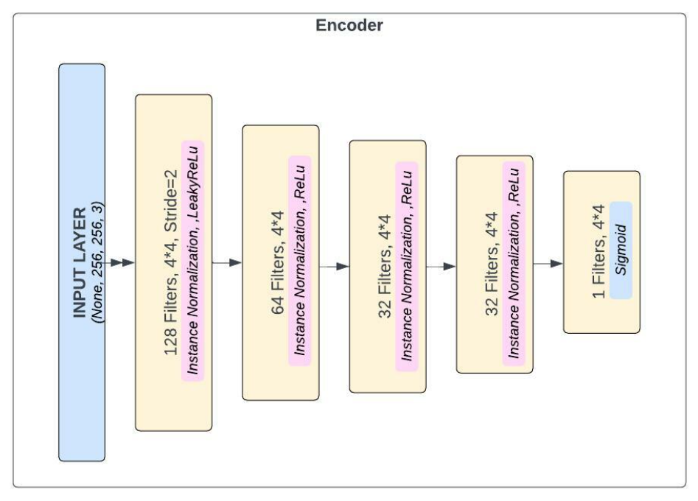

Fig 16. Discriminator Architecture

**Parameters Used in Model:**

HEIGHT = 256

WIDTH = 256

HEIGHT_RESIZE = 128

WIDTH_RESIZE = 128

CHANNELS = 3

BATCH_SIZE = 32

EPOCHS = 100

TRANSFORMER_BLOCKS = 8 # Residual Blocks

GENERATOR_LR = 2e-4 # 3 Generator learning rate

DISCRIMINATOR_LR = 2e-4 # 3 Discriminator learning rate

#### **Model Experiments:**

* Implemented Data Augmentation techniques to increase the training data and for better model performance
* Data augmentations Techniques used - flips, rotations, and crops
* Generator with Encoder, Transformer(with residual blocks) and Decoder layer
* Total 8 transformer blocks works better with our model
* Discriminator with applying better InstanceNorm layer and Leaky ReLU activation function in encoder block on input image and Sigmoid in output layer
* Adam Optimizer used
* Training up-to 200 epochs
* Model Convolution layers initialization worked best for this models
* Residual connection with Concatenate worked great as two image domains aren't very closely related

**Model Justification:**

Cyclegan is a well suited solution to tackle the problem of unpaired image-to-image translations. In this model, we have tried to implement Cyclegan with improved model architecture using better ways of transformation layers to extract the best features of images.

**3) Pix2pix based Cycle-GAN**:

This model is used based on a pre-defined pix2pix generator and discriminator on TensorFlow. It is a conditional generative adversarial network (cGAN) that trains on mapping input images to output images and learns that transformation. In this base pix2pix cGAN, the network architecture will contain a generator and discriminator.

**Generator**:

The generator will be based on the U-Net architecture. These two generators will be imported from the tensorflow_examples library. Some changes include the use of instance normalization instead of batch normalization.. We did not test around with this model much overall since we just want to use it as a basic testing. We explore more options in the DCGAN based cycleGAN and transformation based cycleGAN. It consists of a contracting path (left side) and an expansive path (right side) just like a regular Unet.

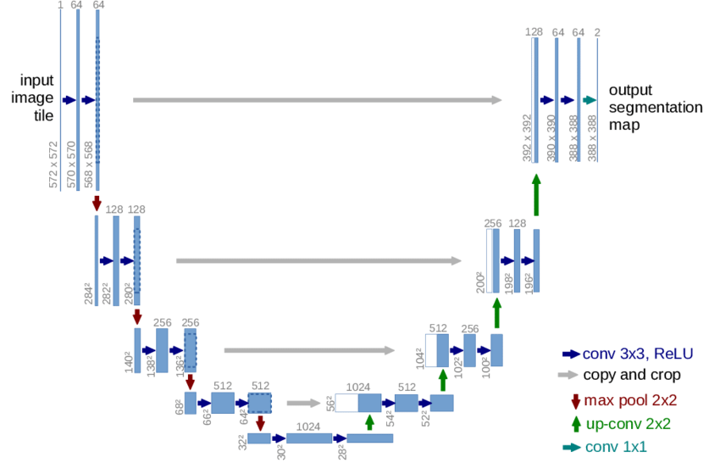

Fig. 17 Generator Unet Architecture

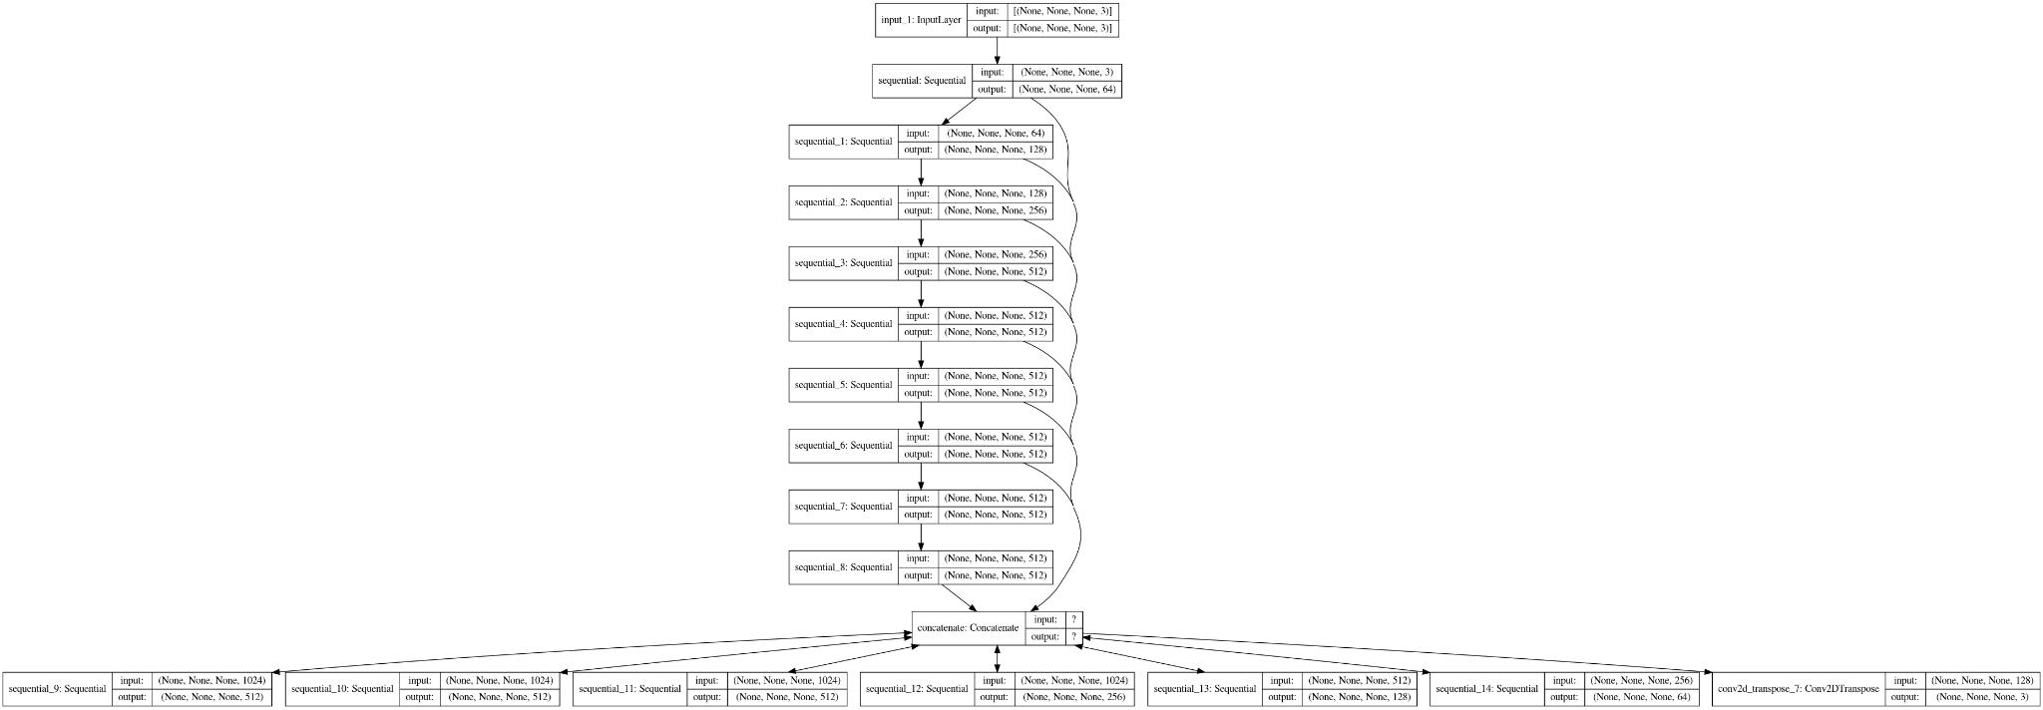

Fig. 18 Summary of Generator Architecture

**Discriminator**:

The discriminator will be a PatchGAN classifier. These two discriminators will be imported from the tensorflow_examples library. The discriminator is a Convolutional Network that is used for adversarial training of the network to differentiate real images from the generated images that have been generated by a generator model.

It is built like most of the previous discriminators, only that not every layer will have instance normalization and an activation function. There will only be a zero padding for the third layer and instance normalization plus ReLU activation function for the fourth layer. The final convolution layer is built with the Sigmoid activation function and generates a dimension of 1 output.

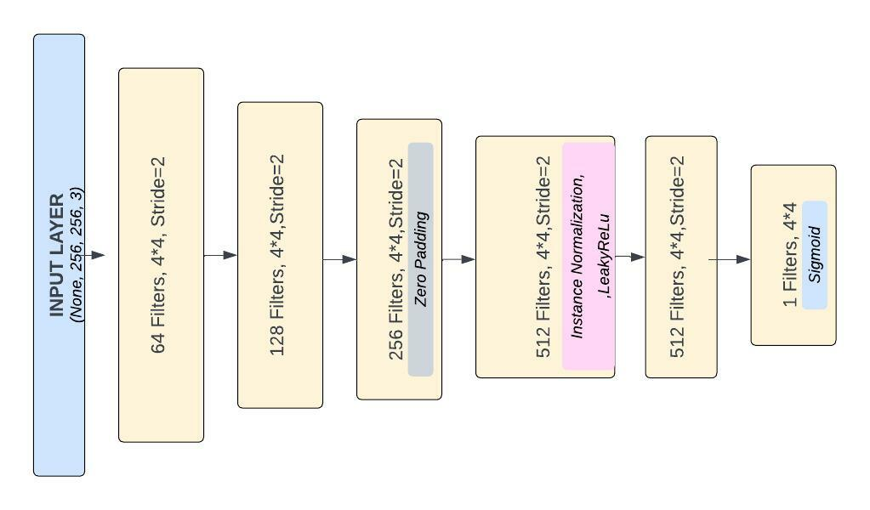

Fig. 19 Discriminator Architecture

**Loss**:

Will be using cycle consistency loss that lets the result be similar to the input as much as possible. The discriminator loss and the generator loss are similar to the ones used in pix2pix.

**Parameters:**

HEIGHT = 256

WIDTH = 256

HEIGHT_RESIZE = 256*1.3

WIDTH_RESIZE = 256*1.3

OUTPUT CHANNELS = 3

BATCH_SIZE = 8

EPOCHS = 50

BETA_1= 0.5

GENERATOR LR = 0.0002

DISCRIMINATOR LR = 0.0002

**Model Justification:**

Pix2pix is a classic and reliable architecture when it comes to paired image-to-image translation. However, it does not work with unpaired images as provided in the competition dataset. That is why we want to try out this Cycle-GAN to see how it would work with unpaired images.

**4) DCGAN based Cycle-GAN**:

Deep Convolutional GANs have multiple blocks of convolutional layers in the model architecture. This helps the generator in generating images by using CNN. In this model architecture instead of using maxpooling or other pooling layers, it uses strided convolutions which allows the model to learn its own upsampling or downsampling.

**Generator**:

Multiple blocks of convolutional layers are used to generate images. No max pooling or fully connected layers are present in the architecture. Instead of pooling layers, fractional-sided convolutions are used. For upsampling, a transposed convolutional layer is used. ReLU is used in all the layers except for the last layer which uses tanh function. There is no batch normalization for the output of the generator.

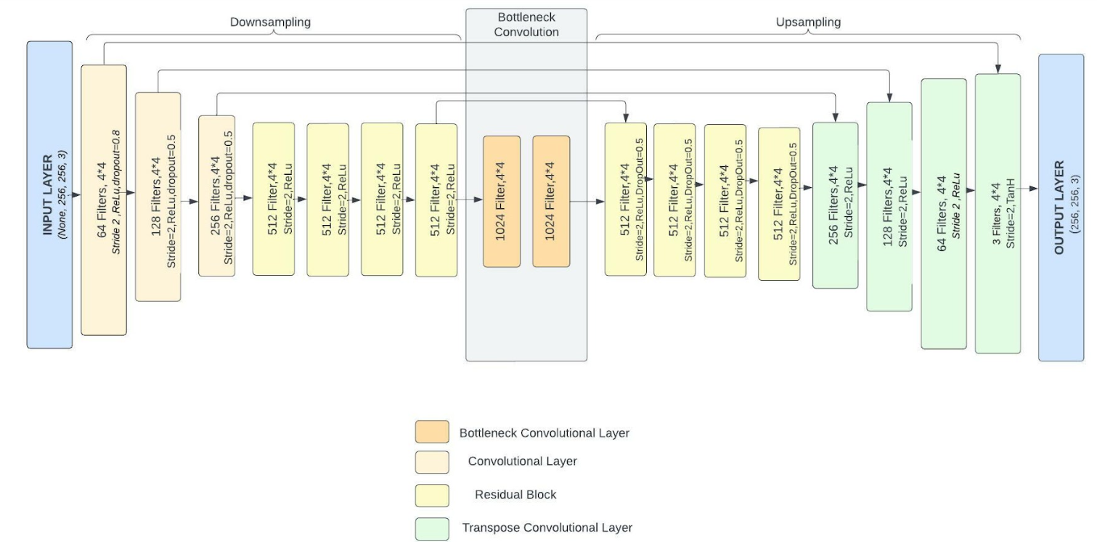

Fig. 20 Generator Architecture

**Discriminator:**

All pooling layers are replaced by strided convolutions. Only LeakyReLU is used in the discriminator in all convolutions. No batch normalization is required for the input to the discriminator anymore.

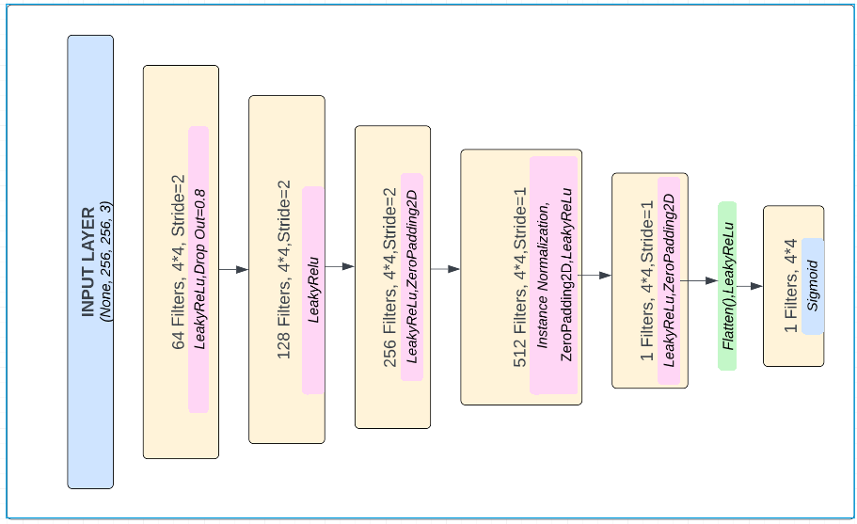

Fig. 21 Discriminator Architecture

**Parameters:**

HEIGHT = 256

WIDTH = 256

HEIGHT_RESIZE = 256*1.3

WIDTH_RESIZE = 256*1.3

OUTPUT CHANNELS = 3

LATENT DIM = 1024

BATCH_SIZE = 32

EPOCHS = 50

BETA_1= 0.9

BETA_2= 0.999

GENERATOR LR = 0.0002

DISCRIMINATOR LR = 0.0002

**Experiments:**

* Tried high drop out for input layer of 0.8.
* Tried training with data augmentation such as color jittering, rotating, flip versus training without data augmentation.
* Adding drop out layers to discriminators.
* Use popular values for beta 1 and beta 2 of adam optimizer which are 0.9 and 0.999 respectively.
* Adam optimizers are the best most of the time so did not use any other optimizer.
* Reduce the down sampling layers in the stack and up sampling layers in the stack to see how the performance would change.
* Use concatenate layer instead of add layer.

**Model Justification:**

DCGAN has good performance and does well with complex image distribution. That is why we wanted to try to apply DCGAN architecture into a cycleGAN to test how it would perform.

**Models Evaluation**

GAN Models are evaluated using Generator and Discriminator Losses. We have two generators and two discriminators in each of the Models.

* Discriminator: It must approve all the original images of the corresponding categories and also reject the images that are generated by corresponding Generators.
* Generators: It must fool the discriminators by making them approve all the generated images and Generators also need to make sure that the generated fake images must retain the property of original image

We are calculating different losses given below to evaluate both the generators and the discriminators

**Identity Loss Function***:*

Mean Squared Error loss function is used to calculate the loss value for generator and discriminator function. The mse loss value is a product of mse and adversarial weight. The role of both models is to minimize the loss value.

**Binary Cross Entropy Loss Function:**

Binary cross entropy compares the predicted class output either 0 or 1 with the actual class output, whether the output image is correctly classifier or not and then it adds the penalty value to the loss score that is the difference in distance between the actual point and the predicted point. Since the problem of discriminator is a binary classification problem, thus binary cross entropy loss provides effective loss value for the generator as well as discriminator.

1. **CycleGAN [ ReLU]:**  
    The below graph plots the training curve of the following model, where the loss evaluation function is mapped over each epoch to show the decrease in loss for the generator function. The loss for the generator is defined as a monet style image for the input photo provided to the model.

**Generator Loss** :

The overall loss for the generator model calculated here after training for 250 epochs is 6.76. The loss at the first epoch was 15.22, which decreased to 6.76.

**Discriminator loss** :

The loss value for discriminator incorrectly classifying the real and fake images. The discriminator loss initially was 2.25 and after training for 250 epoch was 0.1365

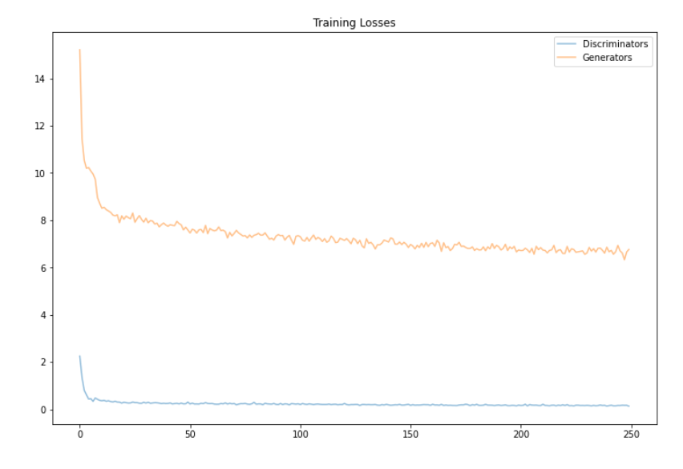

Fig. 22 CycleGAN losses

1. **Improved CycleGAN**:

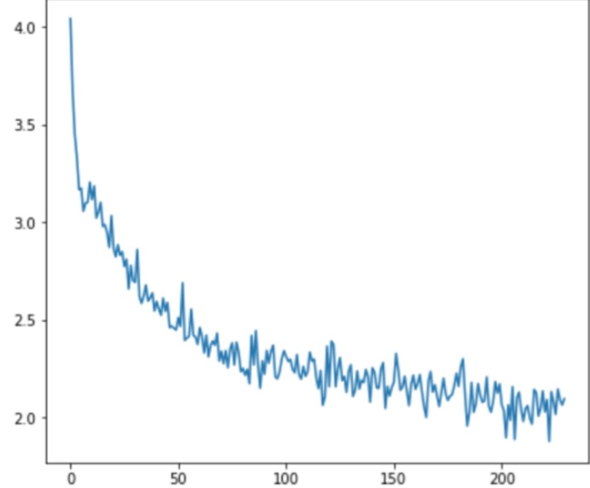

Fig. 23 Improved CycleGAN loss

The graph above provides the overall performance of the model, here the loss function used is the binary cross entropy loss function and is mapped over 200 epochs to see the generator loss value

**Generator Loss :**

The generator loss is reduced from 4.178 to 1.9 at max in 200 epochs.

**Discriminator Loss :**

The discriminator loss was 0.5585 which decreased to 0.4799 in the last epoch.

1. **Pix2pix based CycleGAN:**

The above graph plots the training curve of the pix2pix based model The loss evaluation values are mapped over each epoch to show the changes in loss for the generator function.

**Generator Loss :**

The overall loss for the generator model calculated here after training for 50 epochs is 2.60. The loss at the first epoch was 6.25, which decreased to 2.60.

**Discriminator loss :**

The loss value for discriminator incorrectly classifying the real and fake images. The discriminator loss initially was 0.52 and after training for 50 epoch was 0.2618

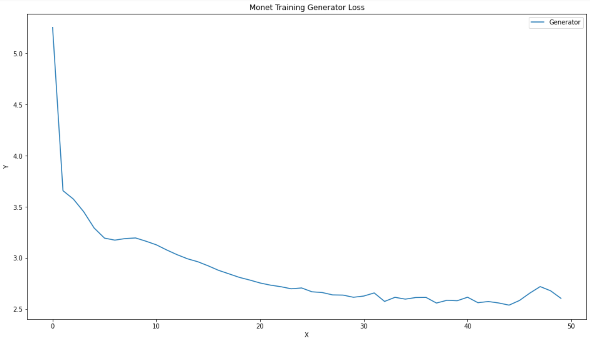

Fig. 24 PIX2PIX loss

1. **DCGAN based CycleGAN:**

The below graph plots the training curve of the DCGAN based model The loss evaluation values are mapped over each epoch to show the changes in loss for the generator function.

**Generator Loss :**

The overall loss for the generator model calculated here after training for 50 epochs is 2.71. The loss at the first epoch was 4.87, which decreased to 2.71.

**Discriminator loss :**

The loss value for discriminator incorrectly classifying the real and fake images. The discriminator loss initially was 0.43 and after training for 50 epoch was 0.31

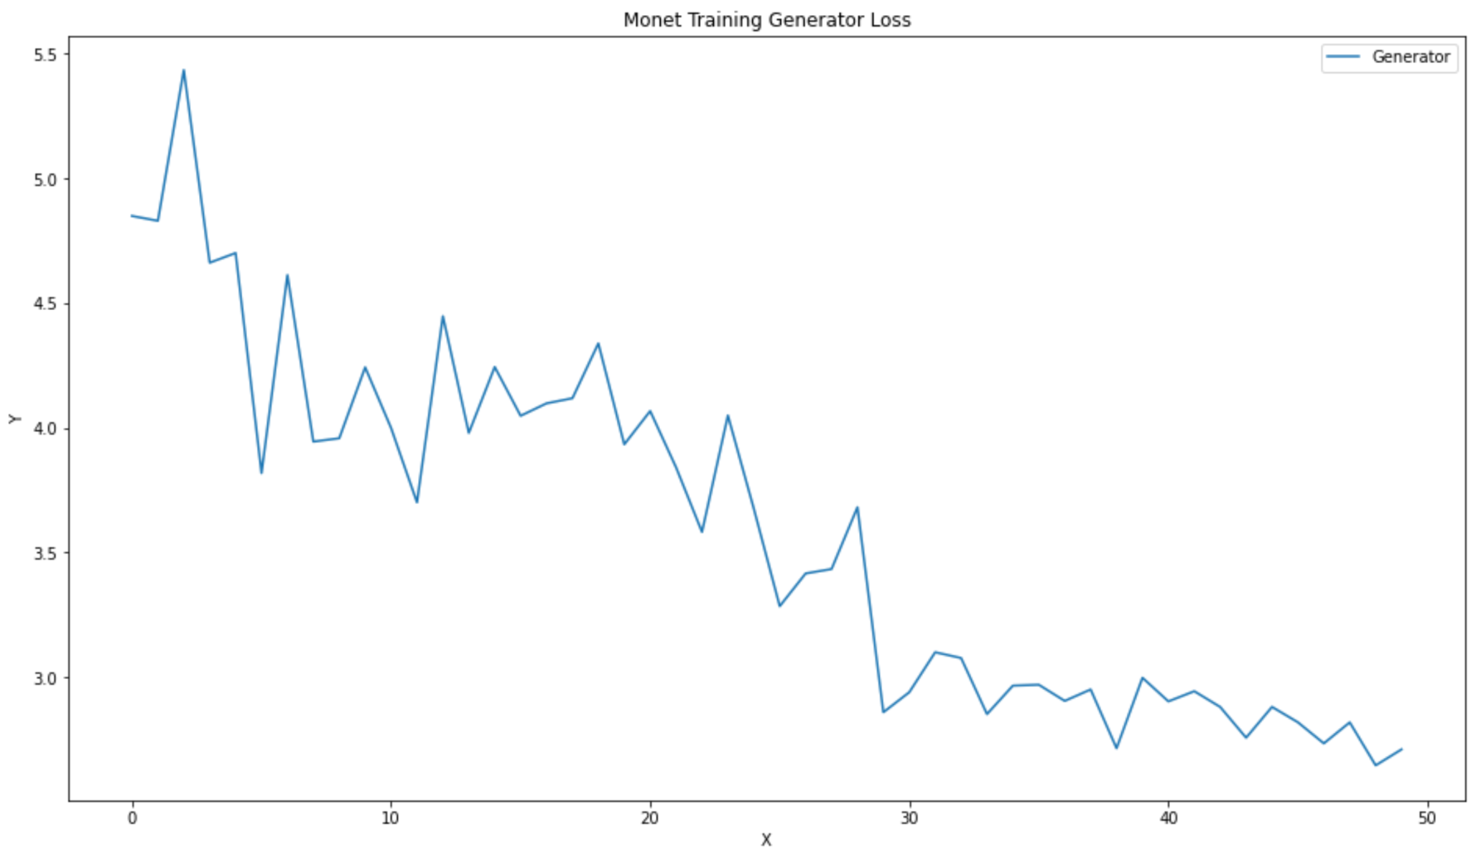

Fig. 25 Best DCGAN loss

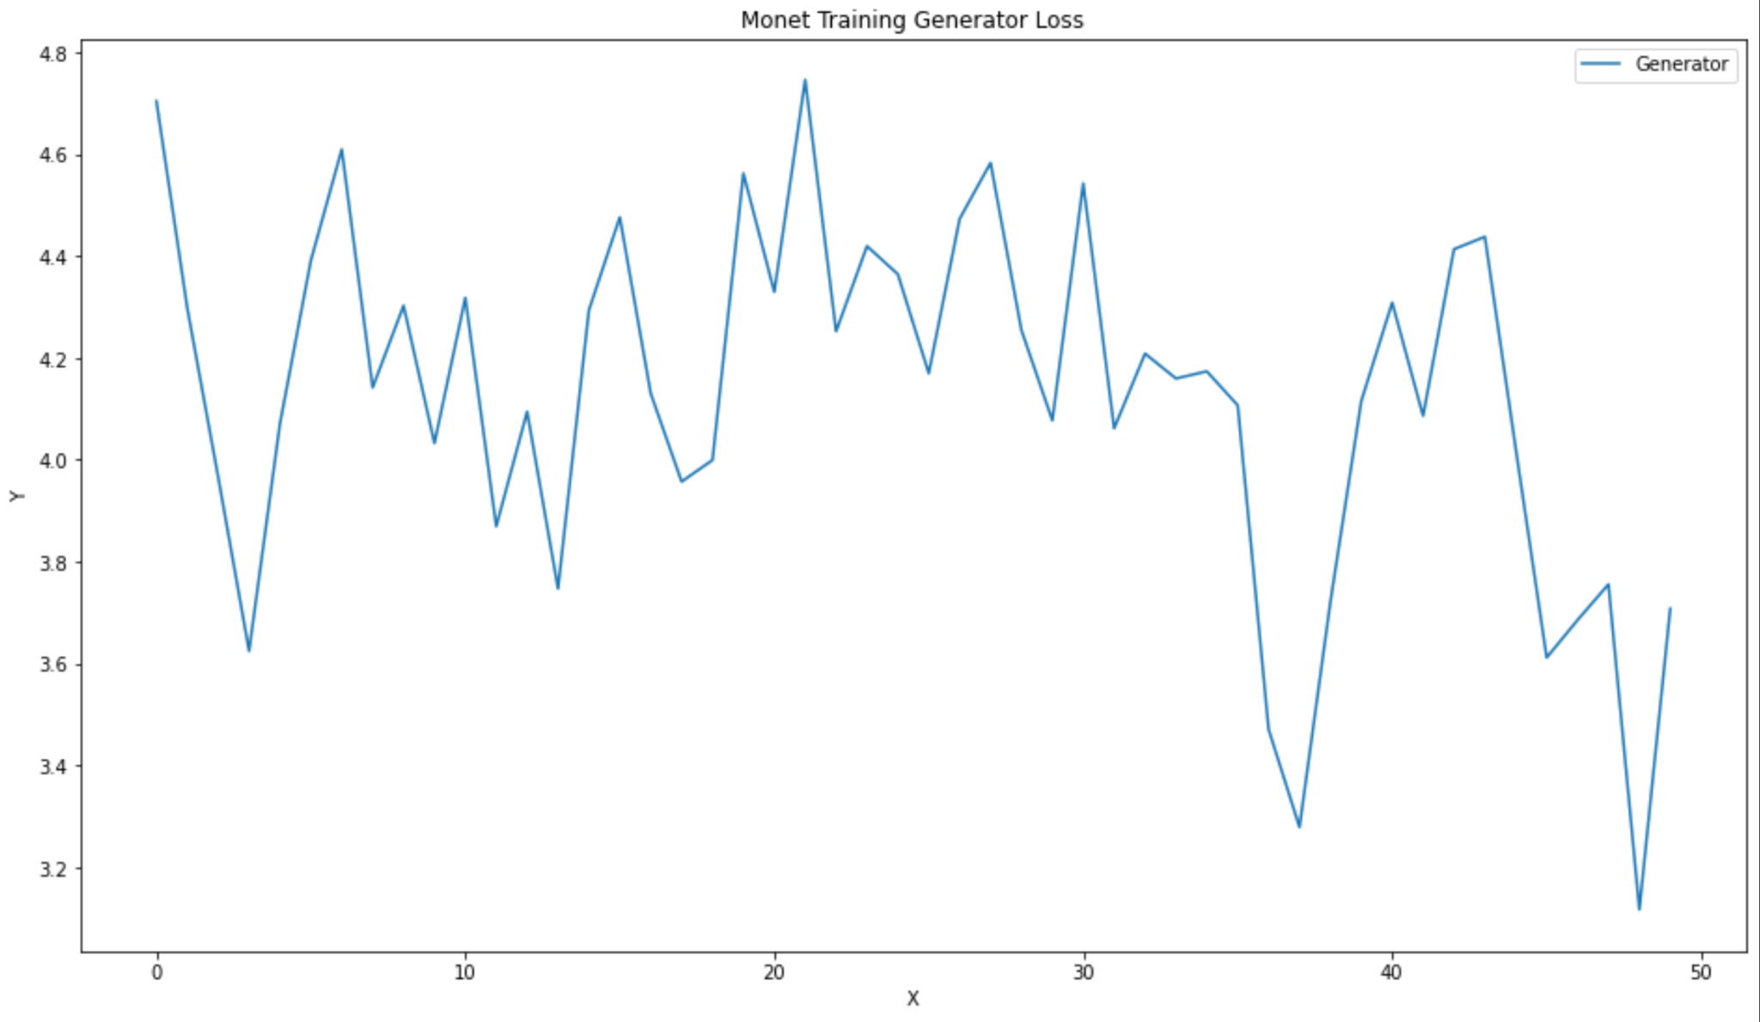

Fig. 26 Monet training Generator Loss

Reduced number of upsample/downsample players of the above

**Result Analysis:**

1. **CycleGAN ReLU:**

The generator and discriminator both use Adam optimizer to train the GAN model. The training comprises 250 total epochs, with generator and discriminator loss calculated for each epoch. The loss function used is Identity loss function, where Mean Squared Error loss is calculated using the mse value of the training epoch and then multiplying it by adversarial weight of the model which is actually the difference of actual and predicted value. The overall loss for the generator model calculated here after training for 250 epochs is 6.76. The loss at the first epoch was 15.22, which decreased to 6.76.

1. **Improved CycleGAN:**

The Generator and Discriminator here also uses Adam optimizer, since the performance of the model is better with Adam optimizer, the operations are performed using it. The model here is trained for 200 epochs, with generator and discriminator loss for both the cycles being calculated. The problem of the discriminator is a binary classification problem, therefore the most effective loss function for such problems which is binary cross entropy loss function is used here. The binary cross entropy loss function penalizes loss value with the difference in distance between the actual and predicted value which would be either 0 or 1. The loss value for the generator function calculated at the first epoch was 3.178 which reduced to the lowest value of 1.9 after 200 epochs, since the loss function used here is different; the value may differ with other loss functions.

1. **Pix2pix based CycleGAN:**

Since Adam optimizer works best most of the time, all our models were run on the Adam optimizer. The binary cross entropy loss function is also being used here. The training comprises 50 total epochs, with generator and discriminator loss calculated for each epoch. The model was run twice of the 50 epochs so it will be 100 epochs in total. The initial loss was 6.25 and after 100 it was lower to 2.60.

1. **DCGAN based CycleGAN:**

This model also used the Adam optimizer all of the time as well as the binary cross entropy function of loss calculation. The changes being made were the layers architecture such as reducing the number of upsampling/downsampling, or learning rate of the generator/discriminator, or the beta values for the Adam optimizer. The training ran 50 total epochs, with generator and discriminator loss calculated for each epoch. The initial loss was 4.87 and after 50 it was lower to 2.71.

**Output visualization:**

1. The input and output visualization of sample images from **CycleGAN using ReLU model**:

Photo dataset:

Fig 27. Input Photo Dataset

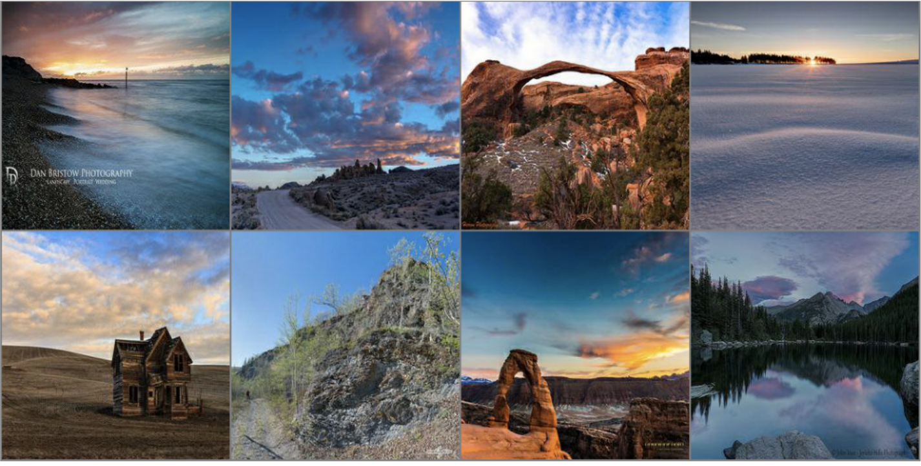

Monet output from GAN:  
 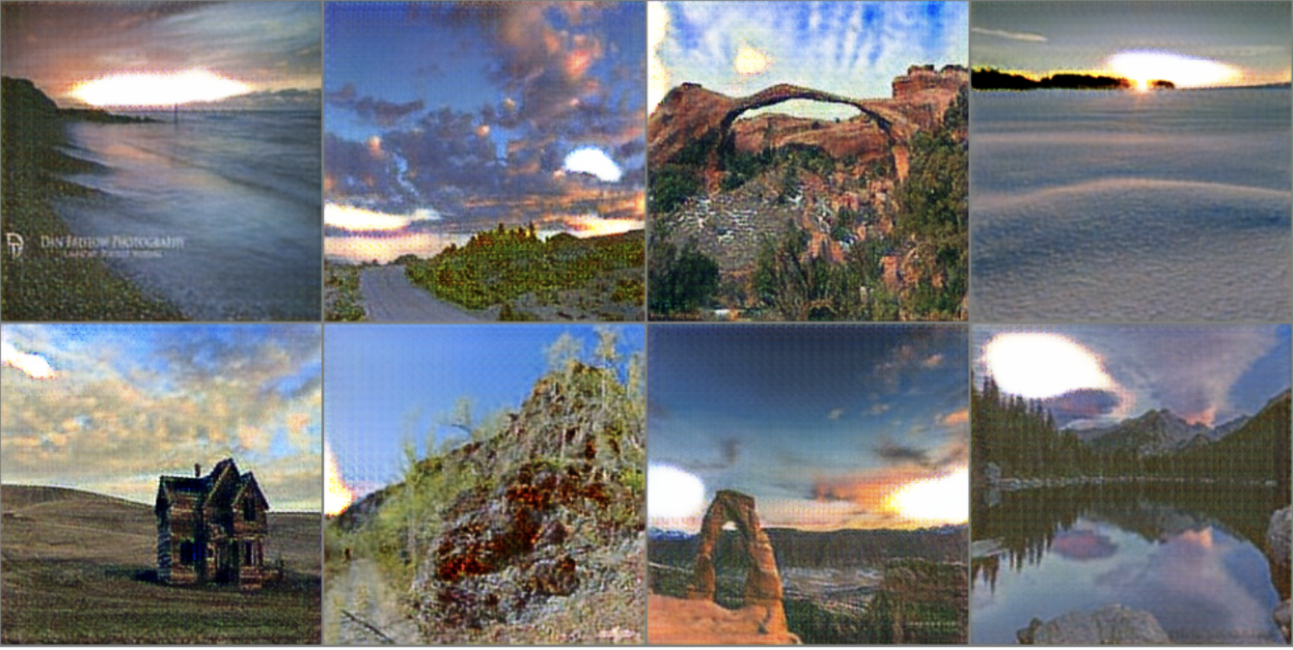

Fig. 28 Output Monet Sample

1. The input and output visualization of sample images from **Improved CycleGAN model**:

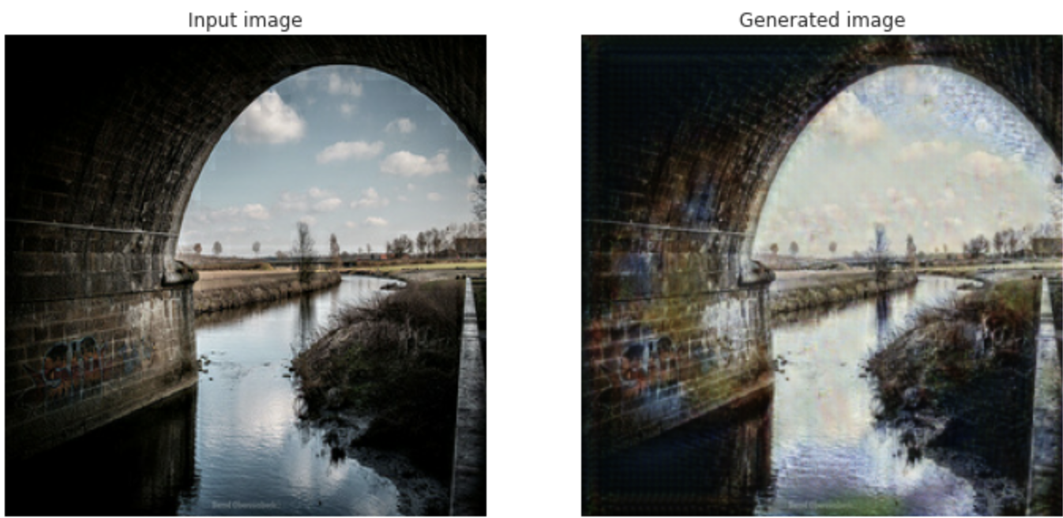

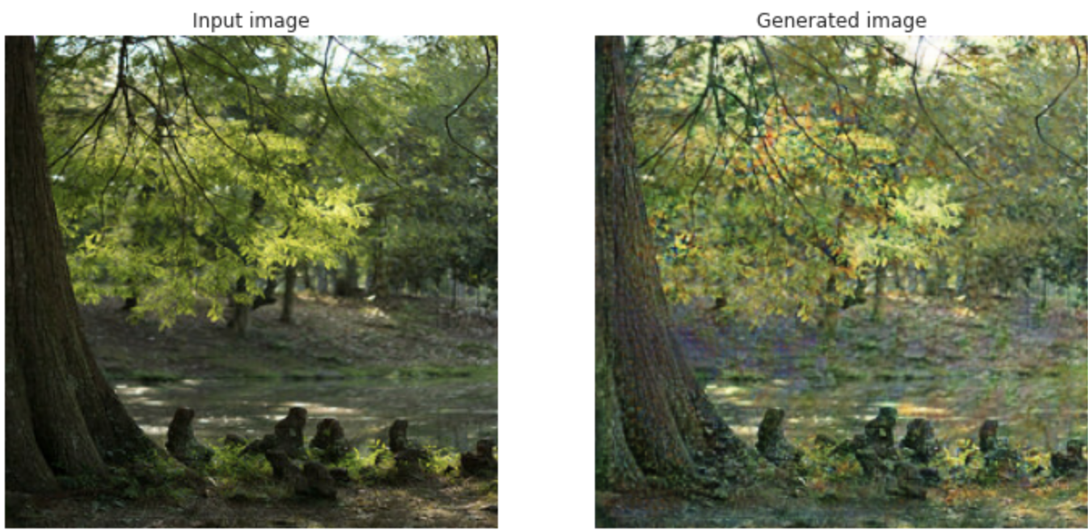

Fig. 29 Sample input and output using Improved CycleGAN

1. The input and output visualization of sample images from **Pix2Pix based CycleGAN model**:

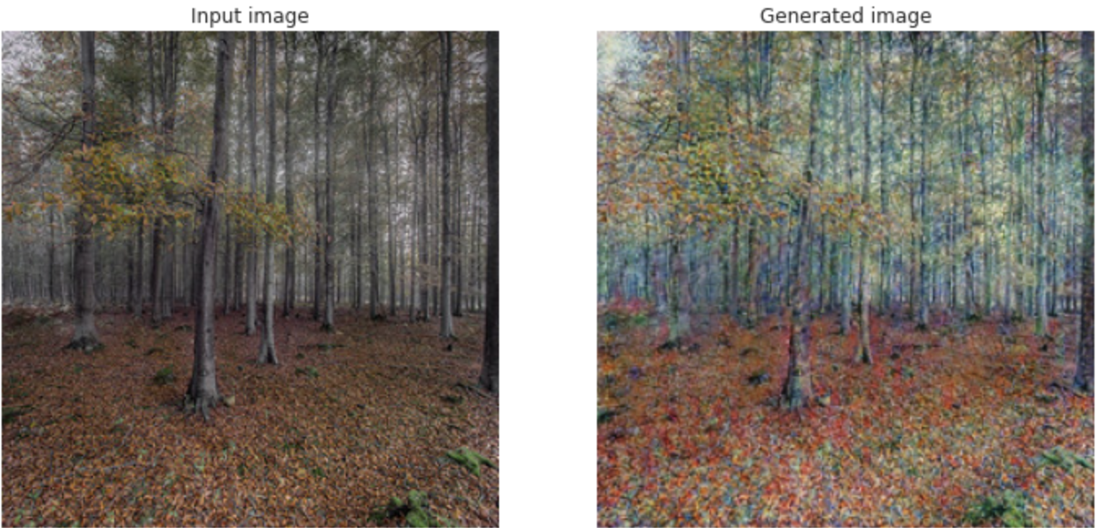

Fig. 30 Input and Output of Pix2pix based CycleGAN model

1. The input and output visualization of sample images from **DCGAN based CycleGAN model**:

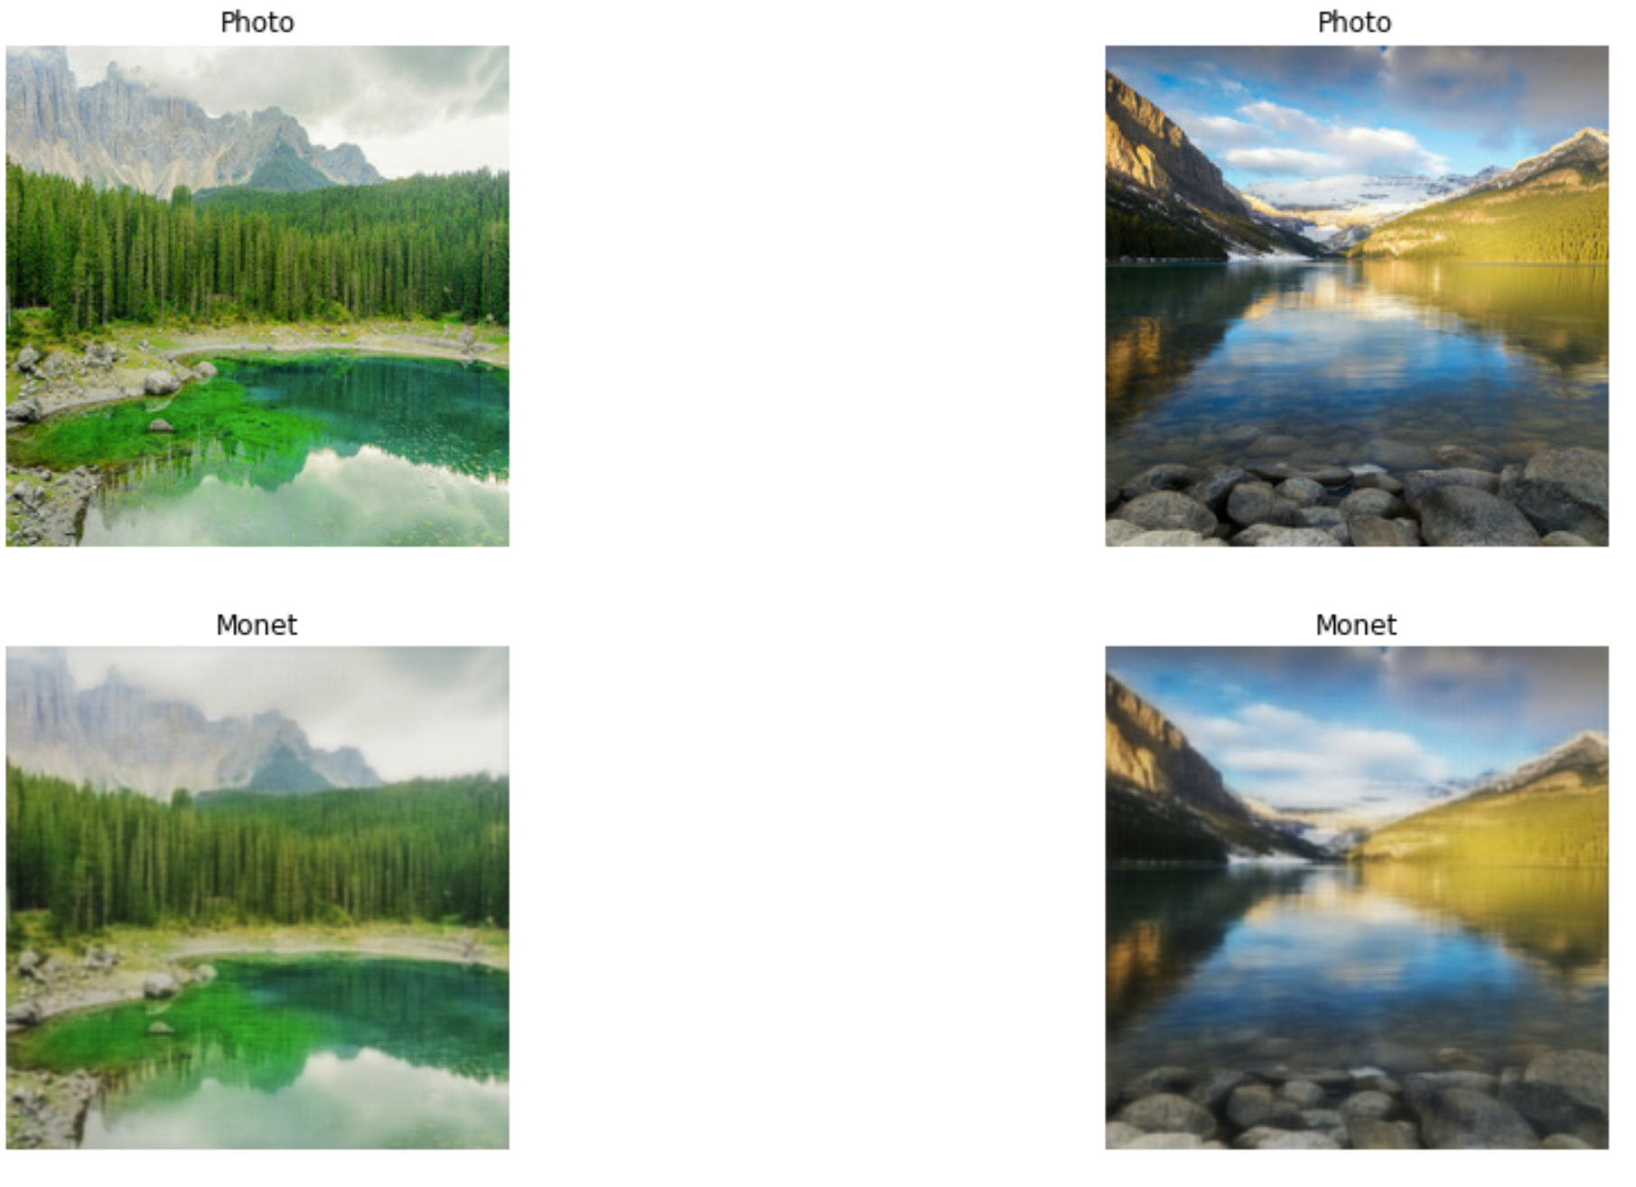

FIg. 31 Input and output of DCGAN model

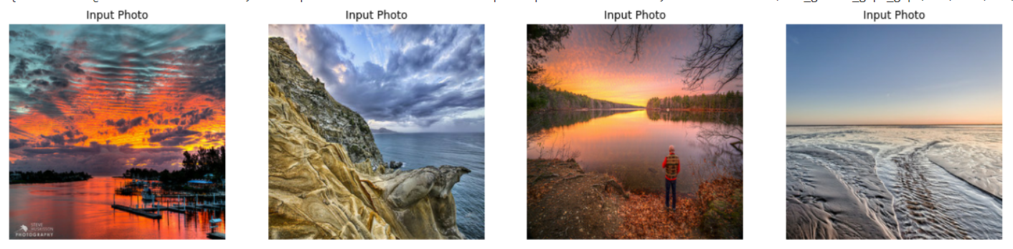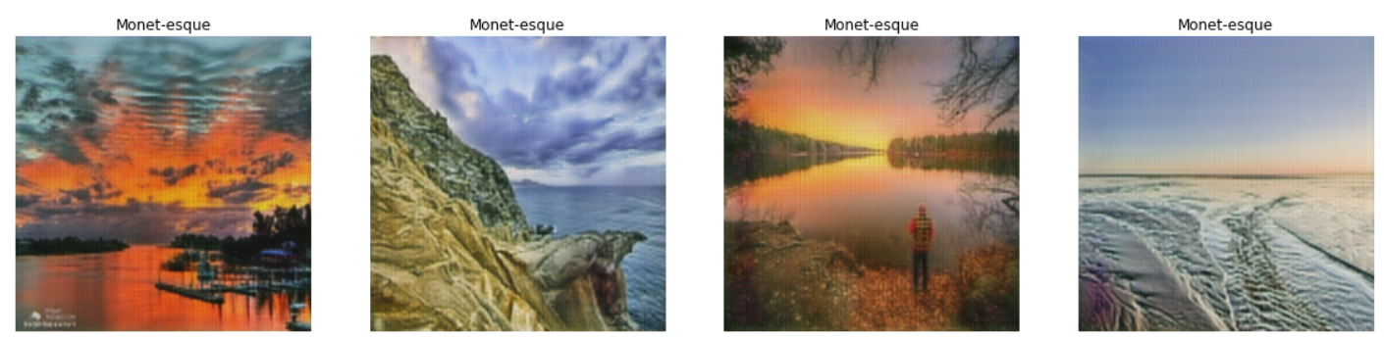

Fig. 32 Input and output images

**Comparative Study**

| **Model** | **G_Loss** | **D_Loss** | **Epoc**h No. | **Time** | **Ressource** |
| --- | --- | --- | --- | --- | --- |
| **CycleGAN wit**h ReLU | **6.76** | **0.13** | **250** | **~3 hours** | **GPU P100** |
| **Improved Cycle GAN** | **1.9** | **0.47** | **200** | **~ 1.5 hours** | **TPU v3-8** |
| **Pix2pix based** | **2.60** | **0.26** | **50** | **~ 1.5 hours** | **TPU v3-8** |
| **DCGAN based** | **2.71** | **0.31** | **50** | **~ 3 hours** | **TPU v3-8** |

We compared each model with respect to the following parameters, generator & discriminator losses, epoch number, time taken for training and resource required as above.

**Conclusion & Future Work**

Based on the statistics in the above table we can clearly see **improved cycle GAN** out performs all the other models. Therefore we choose it as a final model.

In future work, we would experiment further by adding more images and more epochs to further leverage its capabilities.

**References**

1. Improved generative adversarial network and its application in image oil painting style transfer, Image and Vision Computing, Volume 105, 2021, 104087, ISSN 0262-8856, https://doi.org/10.1016/j.imavis.2020.104087.
2. <https://openaccess.thecvf.com/content_CVPR_2019/papers/Qiao_MirrorGAN_Learning_Text-To-Image_Generation_by_Redescription_CVPR_2019_paper.pdf>
3. <http://proceedings.mlr.press/v37/gregor15.pdf>
4. <https://dl.acm.org/doi/pdf/10.1145/3240508.3241386?casa_token=PP4EhnsVi1oAAAAA:kJpFV_OcFyLJuDzlgGA6Xs4Lfndwf7VpuK7ARFMOECIVlWgx9euGlWfOhsKBg2HAySMaRFPwtTZjRw>
5. H. Meng and F. Guo, "Image Classification and Generation Based on GAN Model," 2021 3rd International Conference on Machine Learning, Big Data and Business Intelligence (MLBDBI), 2021, pp. 180-183, doi: 10.1109/MLBDBI54094.2021.00042.
6. Y. Liang and H. Yao, "Research on GAN-based Container Code Images Generation Method," 2020 19th International Symposium on Distributed Computing and Applications for Business Engineering and Science (DCABES), 2020, pp. 198-201, doi: 10.1109/DCABES50732.2020.00059.
7. M. Gong and Y. Wang, "An Feature Image Generation Based on Adversarial Generation Network," 2020 12th International Conference on Measuring Technology and Mechatronics Automation (ICMTMA), 2020, pp. 479-482, doi: 10.1109/ICMTMA50254.2020.00109.
8. <https://jonathan-hui.medium.com/gan-dcgan-deep-convolutional-generative-adversarial-networks-df855c438f>
9. <https://www.kaggle.com/code/dimitreoliveira/improving-cyclegan-monet-paintings/notebook>
10. <https://www.kaggle.com/code/jesperdramsch/understanding-and-improving-cyclegans-tutorial>